BUILDING RESEARCH CAPACITY FOR SUSTAINABLE WATER AND FOOD SECURITY IN DRYLANDS OF SUB-SAHARAN AFRICA (BRECcIA) PROJECT
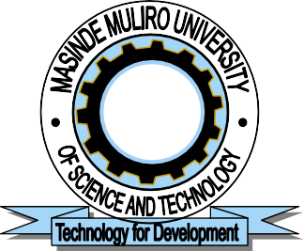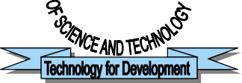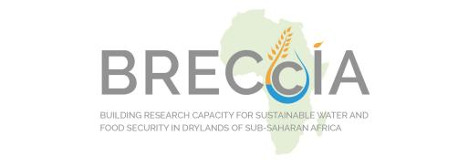
Professional Accredited On-line Course in Research Grants and Contracts Management Course
(14th June to 9th August 2021)
&
On-Site Virtual Training-Managing the Research Grant process
(5th to 7th July 2021)
The BRECcIA consortia brings together Masinde Muliro University of Science and Technology (MMUST), University of Southampton-UoS (UK), University of Nairobi (UoN), Technical University of Kenya (TUK), Kenyatta University (KU), University of Ghana, University of Malawi and eight (8) other international institutions. This is an on-going four (4) year project that started in the year 2017 and is led by the University of Southampton and funded by the Global Challenge Research Fund (GCRF) of the Research Council of United Kingdom (RCUK). The PI of the project is Prof. Justin Sheffield (UoS). The MMUST Research Team is Lead by Mr. Kaleb Mwendwa (SME) supported by Dr. Edward Mugalavai (DMSD), Dr. Humphrey Agevi (Biol. Sciences) and Dr. Daniel Namenya (DMSD) as co-investigators. For more information visit www.gcrf-breccia.com
One of the project partners is the Southern Africa Research Innovation and Management Association (SARIMA https://www.sarima.co.za/) that provides a number of examined accredited Professional Development Courses (PDCs) and Targeted on-line Training Workshops.These are done in conjunction with the Digital Campus of University of Wits (Witswatersrand), South Africa. So far upto 50 MMUST staff both academic and non-academic have participated in the courses. Recently in the period January to May 2021, 5 MMUST staff completed two 8 week on-line self paced PDCs namely Research Ethics and Integrity and Fundamentals of Research Management. SARIMA once again has extended nomination to 10 MMUST staff and researchers to undertake an 8-week (14th June to 9th August) Research Grants and Contracts Management course that will be offered on-line that will culminate in compulsory on-line two and half hours Exam for Certification of Competence. In the intervening period of 5th to 7th July 2021 selected participants (14) from this group will also benefit from a On-site Virtual Training on Managing the Research Grant Process hosted by SARIMA and BRECcIA.
The MMUST BRECcIA Project Team notes that these trainings and courses are being mounted shortly after the Directorate of Research and Post Graduate Support held a successful workshop on Leadership Sensitization on Research Grants Management 7th to 9th June 2021.
On behalf of the BRECcIA PI Prof. Justin Sheffield (UoS), SARIMA Project Manager, Dr. Prenitha Sewnarain, MMUST BRECcIA Research Team and MMUST Division of Research led by Prof. P. Bukhala, the Team Leader (MMUST) wishes all the participants a fruitful engagement in undertaking this course. This course will transfer to all the staff important skills for managing Research using international best practices. Below is the complete list of MMUST participants.

MMUST LIST OF PARTICIPANTS
NAME | SCHOOL | AFFILIATION
- Kaleb A. Mwendwa | School of Education (SEDU) | BRECcIA Co-I & MMUST Team Leader
- Dr. Humphrey Agevi | School of Natural Sciences (SONAS) | BRECcIA Co-I & MMUST Researcher
- Dr. Edward Mugalavai | School of Disaster Management and Humanitarian Assistance (SDMHA) | BRECcIA Co-I & MMUST Researcher
- Dr. Daniel Namenya Naburi | SDMHA | BRECcIA MMUST Post Doc Fellow
- Prof. Peter Bukhala | SPHBMS&T | Director, Research and Post Graduate Support
- Dr. Regina Bwire | SONAS | Lecturer
- Ms. Ruth Songok | SEDU | Lecturer
- Dr.Angela Mungai | School of Business and Economics (SOBE) | Lecturer
- Dr.Anne Musotsi | School is Public health and biomedical sciences and technology (SPHBT) | Lecturer
- Dr. Catherine Aura | SEDU | Snr. Lecturer/Director, DIAL
- Dr. Dennis Omayio | SONAS | Lecturer
- Dr. Lucy Mandillah | School of Arts and Social Sciences (SASS) | Lecturer/D.Director, IIKCS
- Dr. Ruth Simiyu | SDMHA | Lecturer
- Dr. Umulkher Ali | SOBE | Lecturer
- Mr. Peter Otsianda | SDMHA | Administrator/Technician
- Dr. Francis Omoto Orata | SONAS | Snr. Lecturer
- Ms. Ednah Mogaka | SPHBMS&T | Lecturer
- Dr. Issah Kweyu | SPHBMS&T | Lecturer
- Mr. Patrick Kivale, CPA | Finance Department | Grants Accountant

Research Grants and Contracts Management accredited 8 Week On-line course 14th June to 9th August 2021 & SARIMA on Grants Management Training-Second Round of Virtual On-site Training 5-7th July 2021 are funded through the ‘Building REsearch Capacity for sustainable water and food security In drylands of sub-saharan Africa’ (BRECcIA) which is supported by UK Research and Innovation (UKRI) as part of the Global Challenges Research Fund (GCRF), Grant number NE/P021093/1.

